**Week-5 lab b**

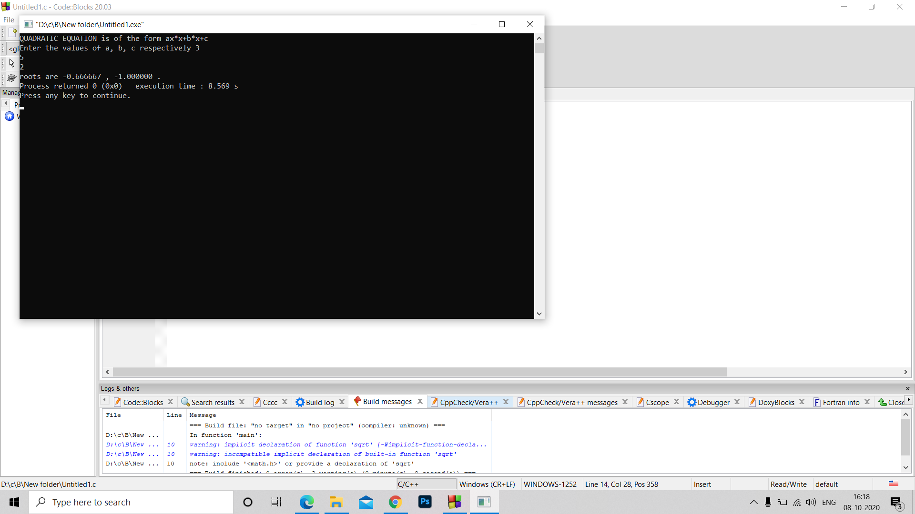Q1. #include<stdio.h>

#include<stdlib.h>

int main ()

{int a,b,c,d;

float r1,r2;

printf("QUADRATIC EQUATION is of the form ax*x+b*x+c \n");

printf("Enter the values of a, b, c respectively ");

scanf("%d%d%d",&a,&b,&c);

d=b*b-4*a*c;

r1=(-1*b + sqrt(d))/(2*a);

r2=(-1*b - sqrt(d))/(2*a);

if(d<0)

printf("no real roots");

else printf("roots are %f , %f .",r1,r2);

}

Q2. #include<stdio.h>

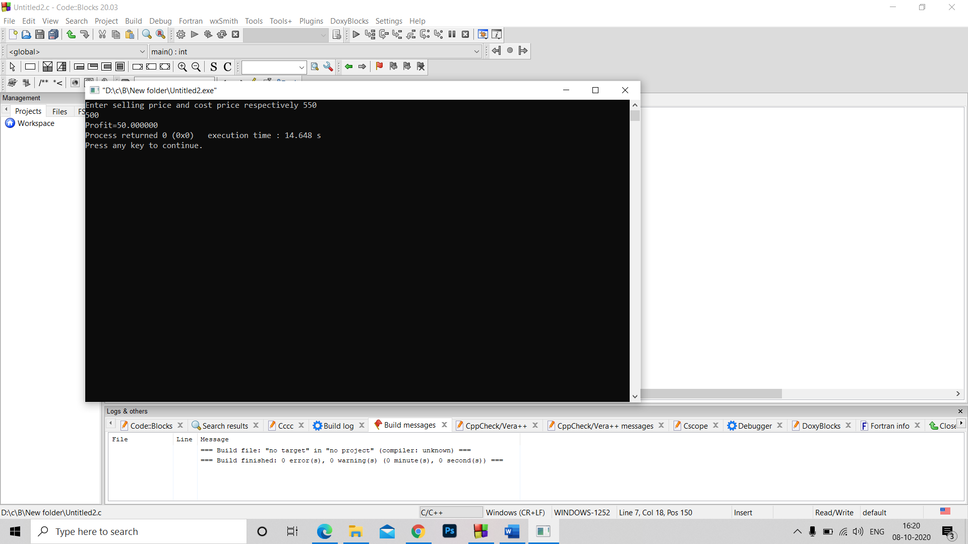#include<stdlib.h>

int main ()

{

float c,s,diff;

printf("Enter selling price and cost price respectively ");

scanf("%f%f",&s,&c);

if(s>c)

printf("Profit=%f",s-c);

else if(c>s)

printf("Loss=%f",c-s);

else

printf("Neither profit nor loss");

}

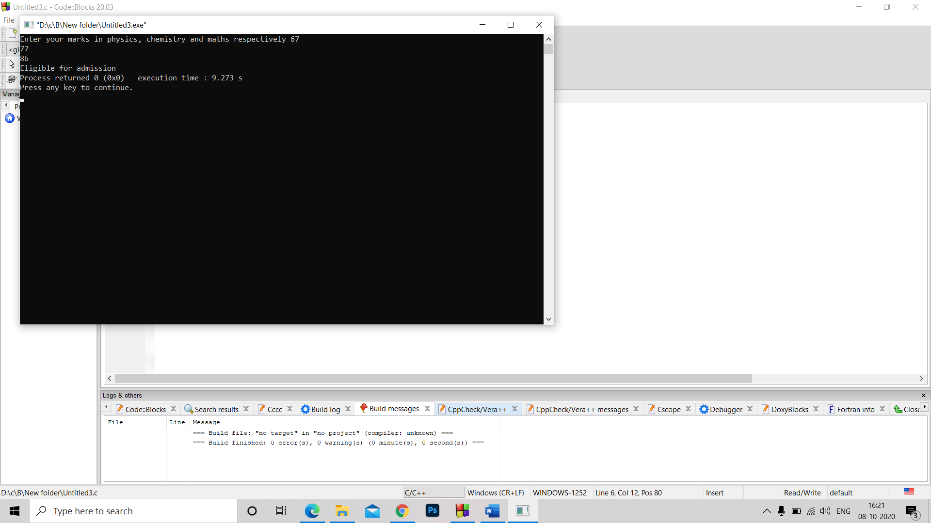Q3. #include<stdio.h>

#include<stdlib.h>

int main ()

{

int p,c,m,t;

printf("Enter your marks in physics, chemistry and maths respectively ");

scanf("%d%d%d",&p,&c,&m);

t=p+c+m;

if((m>=65 && p>=55 && c>=50 && t>=180) || (m+p>=140) || (m+c>=140))

printf("Eligible for admission");

else printf("Not Eligible for admission");

}

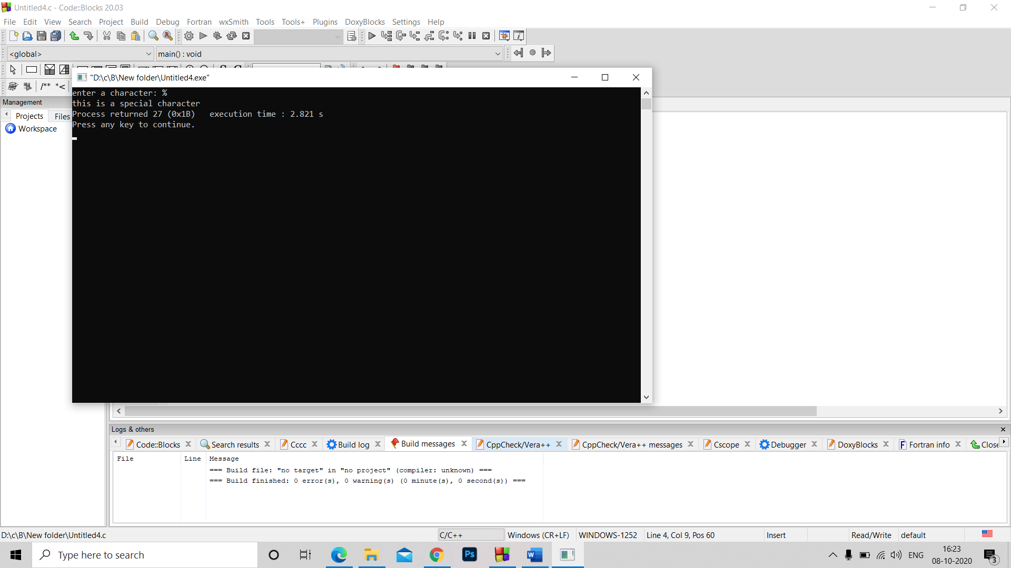Q4. #include<stdio.h>

#include<stdlib.h>

void main()

{char a;

printf("enter a character: ");

scanf("%c",&a);

if(a>='a' && a<='z' || a>='A' && a<='Z')

printf("this is an alphabet");

else if (a>='0' && a<='9')

printf("this is a digit");

else

printf("this is a special character");

}

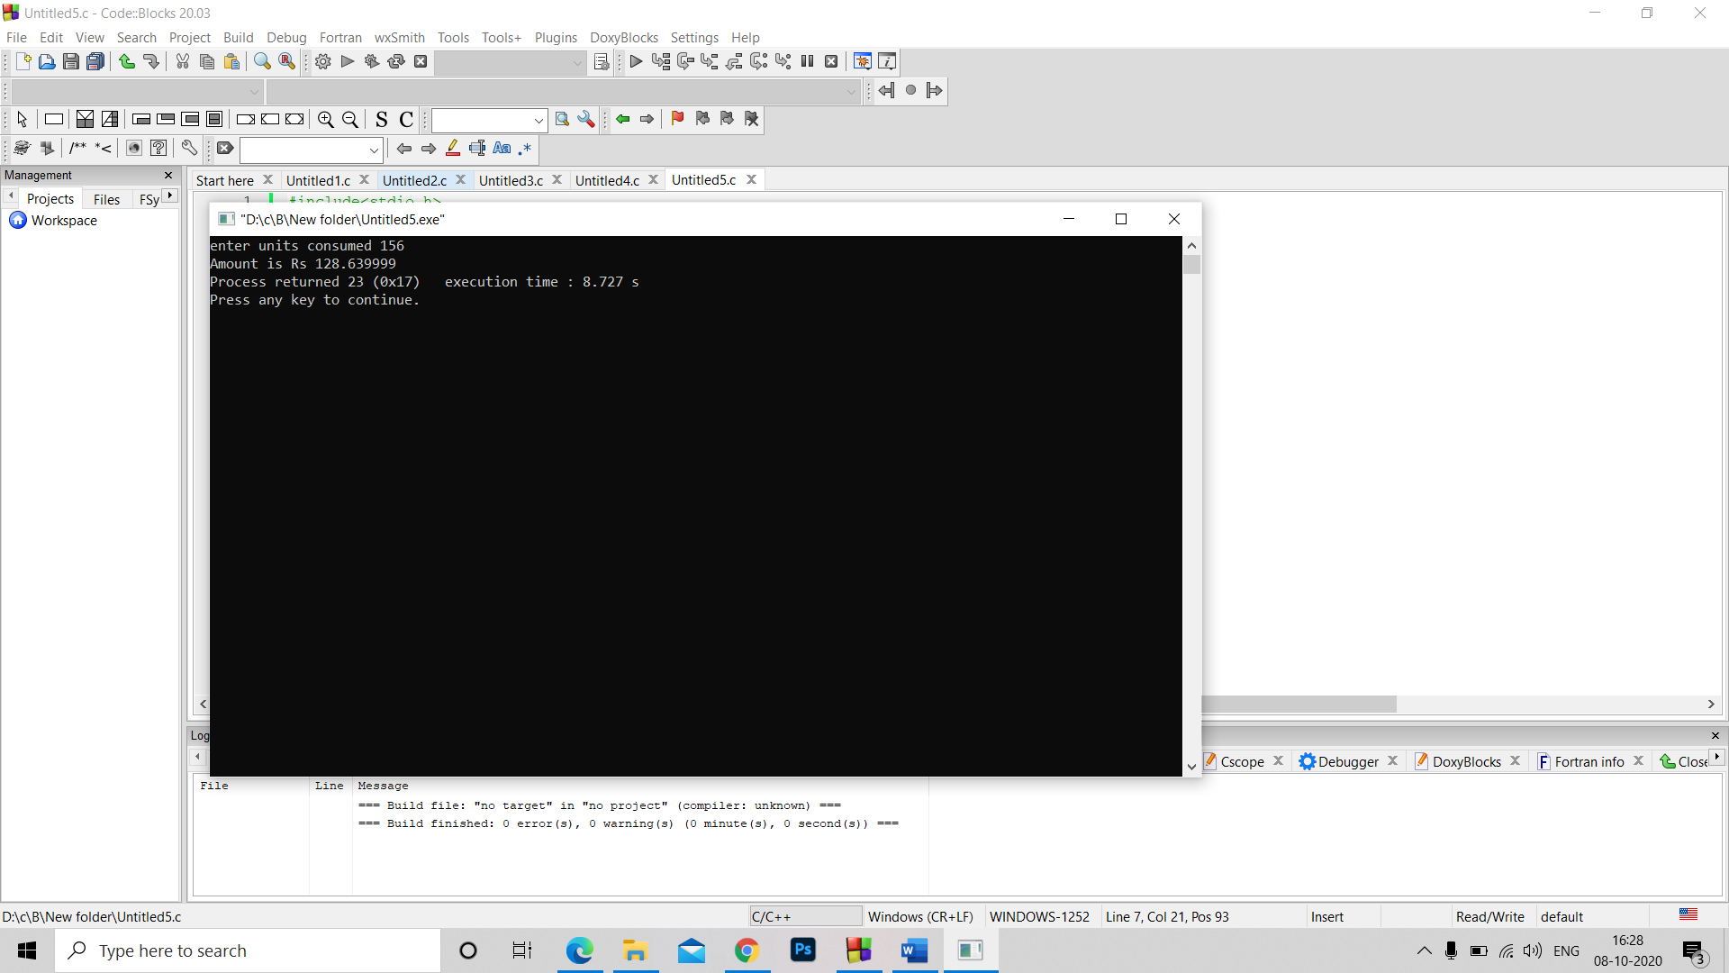Q5. #include<stdio.h>

#include<stdlib.h>

void main()

{

int c;

float A;

printf("enter units consumed ");

scanf("%d",&c);

if(c<=50)

A= 0.5*c;

else if(c>50 && c<=150)

A=(c-50)*0.75+50*0.5;

else if(c>150 && c<=250)

A=100*0.75+50*0.5+(c-150)*1.2;

else if(c>250 )

A=100*0.75+50*0.5+100*1.2+(c-250)*1.5 ;

A=A+0.2*A;

printf("Amount is Rs %f",A);

}